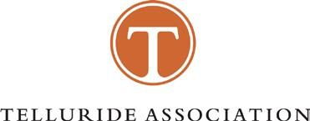
MANSFIELD-WEFALD SENIOR THESIS PRIZE
2022
The 1994 Telluride Association Convention established the Mansfield-Wefald Prize to honor the memory of Mary Mansfield and Eric Wefald, two Association members who died tragically in 1989. The prize of $1,000 will be awarded by a committee of Association members for the best scholarly thesis written by a Telluride associate who will have completed their final year of undergraduate education in the 2021-22 academic year. The committee may choose to split the prize equally among multiple associates in the event that the committee judges that multiple theses merit the prize.

To apply, complete the information below and send this form, a 1- to 2-page thesis abstract, and a digital copy of the thesis to the Ann Arbor Office (mpm@tellurideassociation.org). Please put “Mansfield-Wefald Thesis Prize” in the subject line. Please remove name and identifying information from the thesis document and file name itself as an anonymous process is fairer to all applicants.

The deadline this year is May 6, 2022 at 5pm Eastern time. Every applicant MUST submit a complete copy of this form by the above deadline to be considered. Potential applicants with later thesis deadlines may request permission to submit the actual thesis and abstract later than this date by writing in advance of May 6, 2022 at 5pm Eastern time to Michigan Program Manager at mpm@tellurideassociation.org.

Name: | ___________________________________________
Telluride Affiliation: | ___________________________________________
Mailing Address: | ___________________________________________  ___________________________________________
Phone: | ___________________________________________
E-mail:  Academic | ___________________________________________
Institution: | ___________________________________________
Thesis Title: | ___________________________________________
The Mansfield-Wefald Senior Thesis Prize will be announced in June 2022.
Please contact mpm@tellurideassociation.org for questions or more information.

